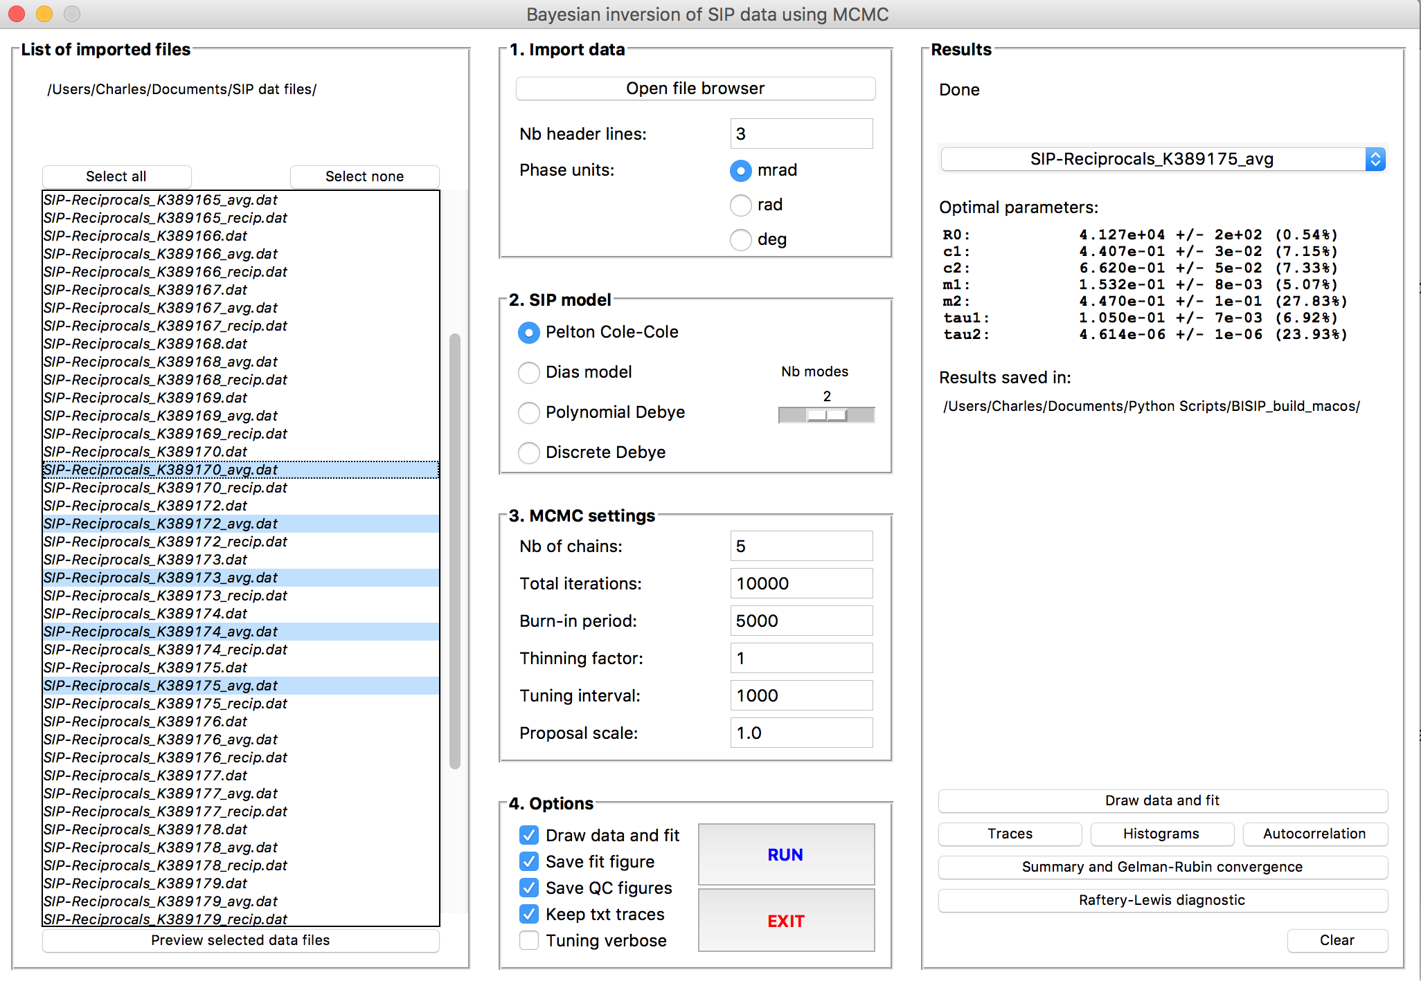

1. **Import data**
   1. Open file browser
   2. Select files to import
   3. Specify the number of header lines (if data has column titles)
   4. Specify the phase units in data file (milliradians, radians, or degrees)
   5. Data files are column separated ascii files of any extension
   6. Example of data files is included in the help menu
   7. All files must be in the same directory and the same extension
   8. The path to files can be copied from the user interface
   9. Items in the imported files listbox can be selected 1-by-1, by using the ctrl and shift modifiers, or using the “Select all” and “Select none” buttons
   10. Phase, amplitude and Nyquist plots can be previewed using the “Preview selected data files” button
2. **Spectral IP model**
   1. Select the desired spectral IP model. See help menu for a list of references
   2. For Pelton Cole-Cole model: specify the number of relaxation modes (1, 2, 3)
   3. For Debye decomposition:
      1. Specify the order of the polynomial approximation (3, 4 or 5)
3. **MCMC parameters**
   1. See MCMC parameters in help menu
   2. Enter an integer for number of chains (e.g. 1), total sampling iterations (e.g. 10 000), burn-in period (iterations to discard, e.g. 8000), thinning factor (e.g. 1) and tuning interval (e.g. 1000). Enter a float for proposal distribution scale (e.g. 1.0).
4. **Batch options**
   1. Draw data and fit: If checked, will open a window and plot the phase, amplitude, and Nyquist plots of the raw data and the optimal model after all iterations are complete
   2. Save fit figure: If checked, will automatically save the data and fit figure, even if “Draw data and fit” is unchecked. This will also save the relaxation time distribution if the Debye decomposition model is selected
   3. Save QC figures: If checked, will automatically save the histograms, autocorrelation, traces and summary figures
   4. Save txt traces: If checked, will automatically save all the information from MCMC sampling in txt files labelled by date, model and computer time
   5. Verbose: Will print the information on tuning during the sampling process (to track acceptance ratio)
   6. RUN inversion will run inversion only on the files highlighted in the “List of imported files” listbox. If multiple files are selected batch inversion will start
   7. All automatically saved figures are stored in the corresponding folders in the same directory where the executable is placed
5. **Results**
   1. Dropdown menu with completed inversion files
   2. Optimal parameters can be copied from the user interface
   3. Optimal parameters and statistics are automatically saved in csv files in a “Results” folder in the executable’s directory
   4. Result files are labelled with raw data file name and inversion model used
   5. Draw data and fit: Will open a window and plot the phase, amplitude, and Nyquist plots of the raw data and the optimal model
   6. If Debye decomposition is selected: A button to draw the relaxation time distribution is available
   7. Traces: Opens a window and plot parameter traces
   8. Histograms: Open a window and plot parameter histograms
   9. Autocorrelation: Open a window and plot parameter autocorrelation
   10. Summary and Gelman-Rubin convergence: Will run the pymc G-R convergence diagnostic, open a window and plot the results. More than 1 chain is required for G-R diagnostic
   11. Raftery-Lewis diagnostic: Will run the pymc R-L diagnostic and print the required MCMC parameters for convergence.